Wild Card Certificate Needs

Miami Dade Wild Card Certificate Needs for Tanzu Platform Cloud Foundry (TPCF).

Each cloud foundry installation is known as a foundation.

The installation for TPCF foundations uses 2 wildcard certs. Typically, installation uses two like the following:

*.sys.<domain-name>

*.apps.<domain-name>

Where <domain-name> is the fqdn you own.

The [TPCF install instructions](https://techdocs.broadcom.com/us/en/vmware-tanzu/platform/tanzu-platform-for-cloud-foundry/10-0/tpcf/config-domains.html) describe how the 2 domain names are used:

* The **system domain** defines your target when you push apps to Tanzu Platform for Cloud Foundry, such as your load balancer. Tanzu Platform for Cloud Foundry assigns system components such as UAA and Apps Manager to subdomains under this domain.
* The **apps domain** is the default domain that apps use for their hostnames. Tanzu Platform for Cloud Foundry hosts each app at subdomains under this domain. You can use the Cloud Foundry Command Line Interface (cf CLI) to add or delete subdomains assigned to individual apps.

TPCF Installation also needs any all the certs from the cert chain to the Cert Authority, i.e. Intermediate certs and the CA.

This is a high level view of Cloud foundry Architecture for routing from this [reference](https://techdocs.broadcom.com/us/en/vmware-tanzu/platform/tanzu-platform-for-cloud-foundry/6-0/tpcf/cf-routing-architecture.html):.

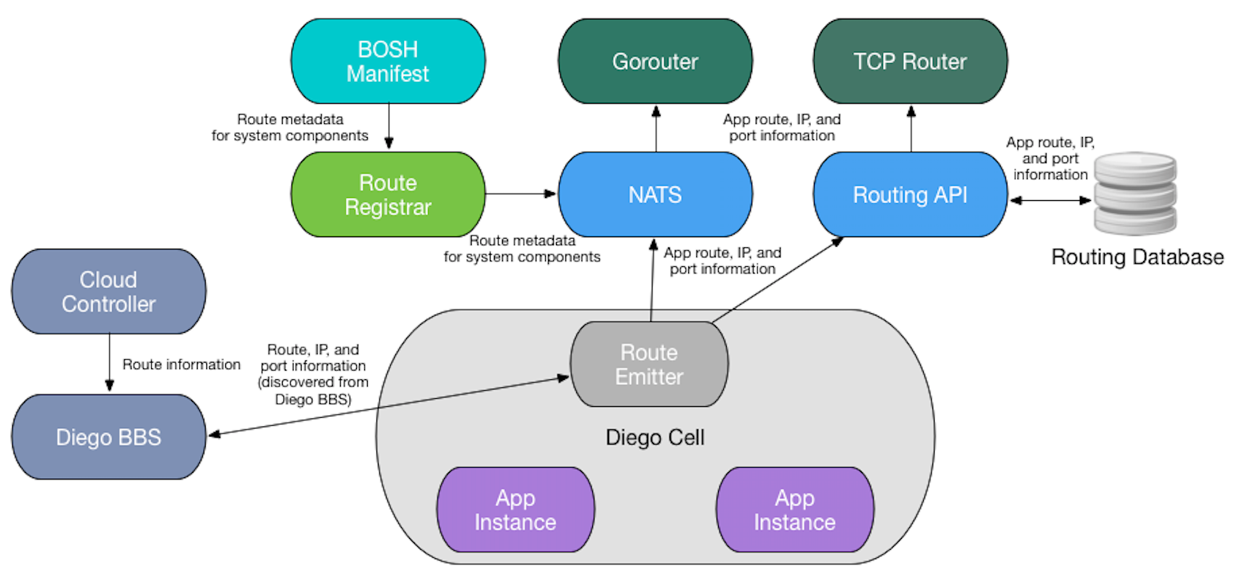

The first cert terminates at the Gorouter. All Application traffic is then routed to the appropriate container by the Gorouter via a url using a specific fqdn name like “app1.apps.<domain-name>”